Create a Matrix Report
Step 1: Same as Tabular report only changes are from Report Type
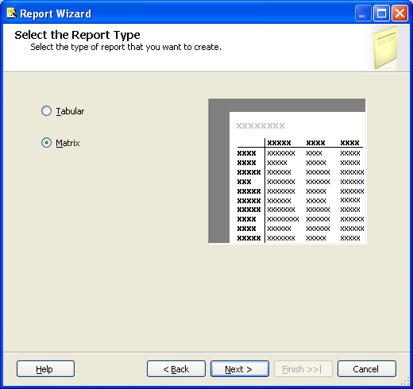
Step 2: Design the Matrix
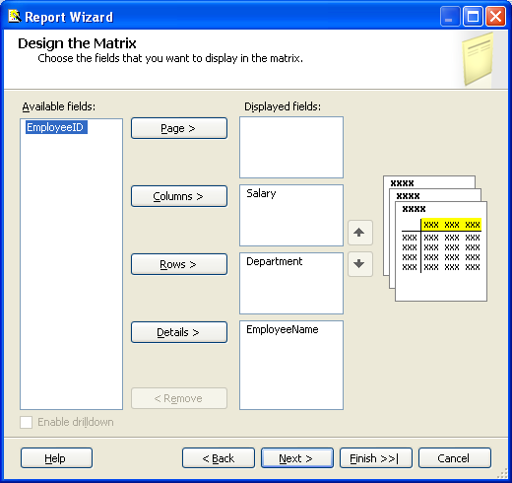
Step 3:
